**6. Kubernetes Service Demo with External DNS**

--- Reference - <https://github.com/stacksimplify/aws-eks-kubernetes-masterclass/tree/master/08-NEW-ELB-Application-LoadBalancers/08-08-Use-ExternalDNS-for-k8s-Service>

--- in this lesion, we will use kubernetes service with external dns.

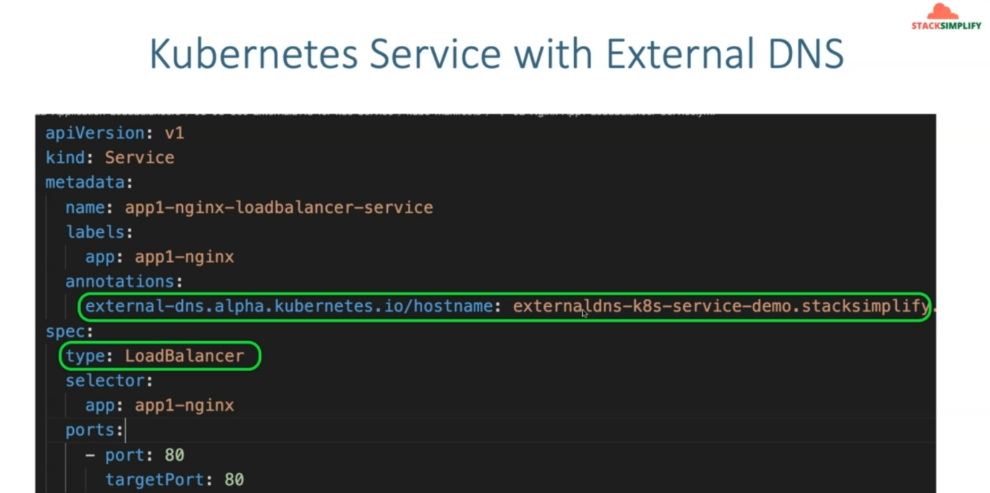

--- which means Kubernetes service off type load balancer. We are going to add that external DNS annotation here and we are going to provide that DNS name here and the application, whatever you are going to deploy with this respective load balancer service. So, you are going to now access it directly with the custom DNS, whatever you have created.

**Network design**

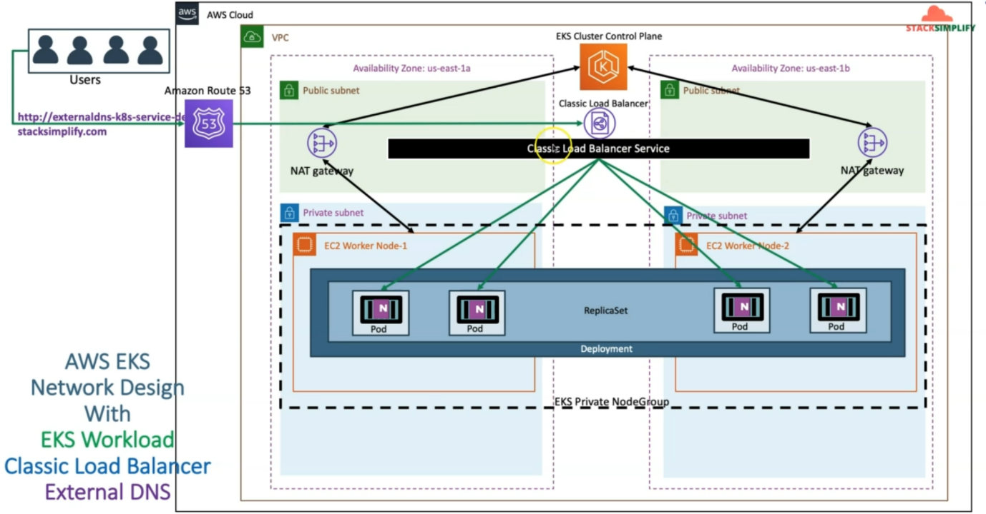

--- So, the Kubernetes service off type load balancer creates a classic load balancer in aws and its DNS name will be registered as alias in the Route53 for the external DNS name, whatever you have specified.

--- whenever you access external DNS <http://externaldns-k8s-service-demostacksimplify.com>. The request will come to Classic Load Balancer and from there you'll be able to access your application pods. load balancer under this respect to load balancer.

--- Let's go back to our GitHub repository

**Introduction**

--- We will create a Kubernetes Service of type: LoadBalancer

--- We will annotate that Service with external DNS hostname external-dns.alpha.kubernetes.io/hostname: externaldns-k8s-service-demo101.stacksimplify.com which will register the DNS in Route53 for that respective load balancer

--- **02-Nginx-App1-LoadBalancer-Service.yml**

apiVersion: v1

kind: Service

metadata:

  name: app1-nginx-loadbalancer-service

  labels:

    app: app1-nginx

  annotations:

    external-dns.alpha.kubernetes.io/hostname: externaldns-k8s-service-demo101.stacksimplify.com

spec:

  type: LoadBalancer

  selector:

    app: app1-nginx

  ports:

    - port: 80

      targetPort: 80

--- **01-Nginx-App1-Deployment.yml**

apiVersion: apps/v1

kind: Deployment

metadata:

  name: app1-nginx-deployment

  labels:

    app: app1-nginx

spec:

  replicas: 1

  selector:

    matchLabels:

      app: app1-nginx

  template:

    metadata:

      labels:

        app: app1-nginx

    spec:

      containers:

        - name: app1-nginx

          image: stacksimplify/kube-nginxapp1:1.0.0

          ports:

            - containerPort: 80

**Deploy & Verify**

**# List the files in kube-manifests**

--- **ls -lrt kube-manifests**

**# Deploy kube-manifests**

--- **kubectl apply -f kube-manifests/**

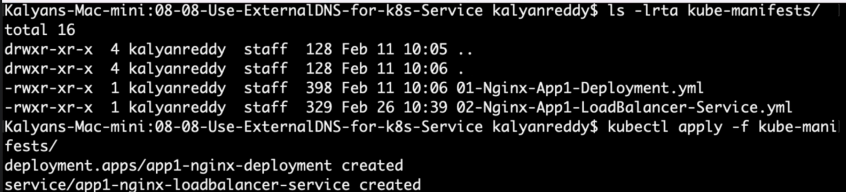

**# Verify Apps**

--- **kubectl get deploy**

--- **kubectl get pods**

**# Verify Service**

--- **kubectl get svc**

**Verify Load Balancer**

--- Go to EC2 -> Load Balancers -> Verify Load Balancer Settings

**Verify External DNS Log**

**# Verify External DNS logs**

--- **kubectl logs -f $(kubectl get po | egrep -o 'external-dns[A-Za-z0-9-]+')**

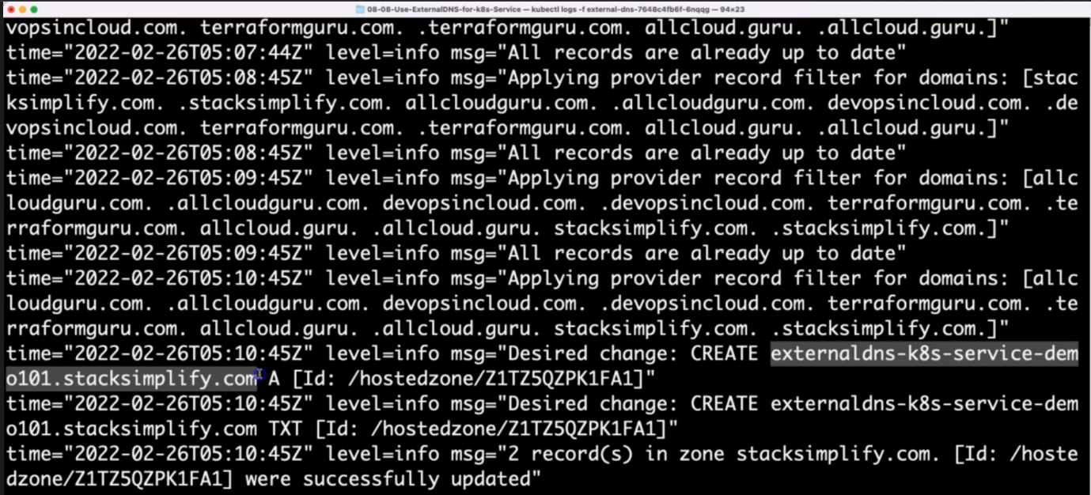

--- **note** - it had created the external dns in hosted zone. 2 records in zone stacksimplify.com were updated.

**Verify Route53**

--- Go to Services -> Route53

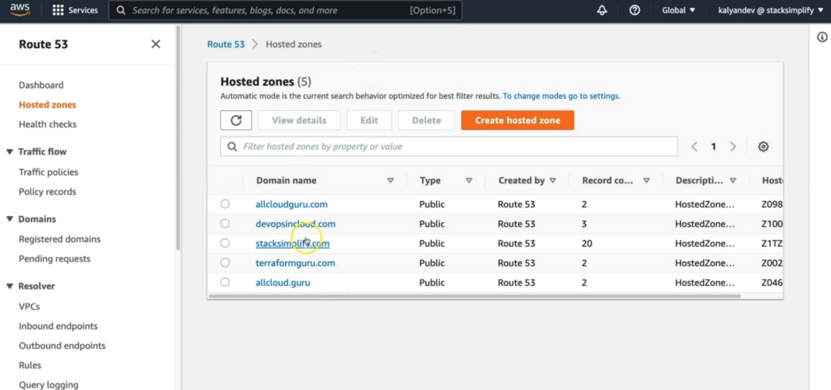

--- click on stacksimplify.com.

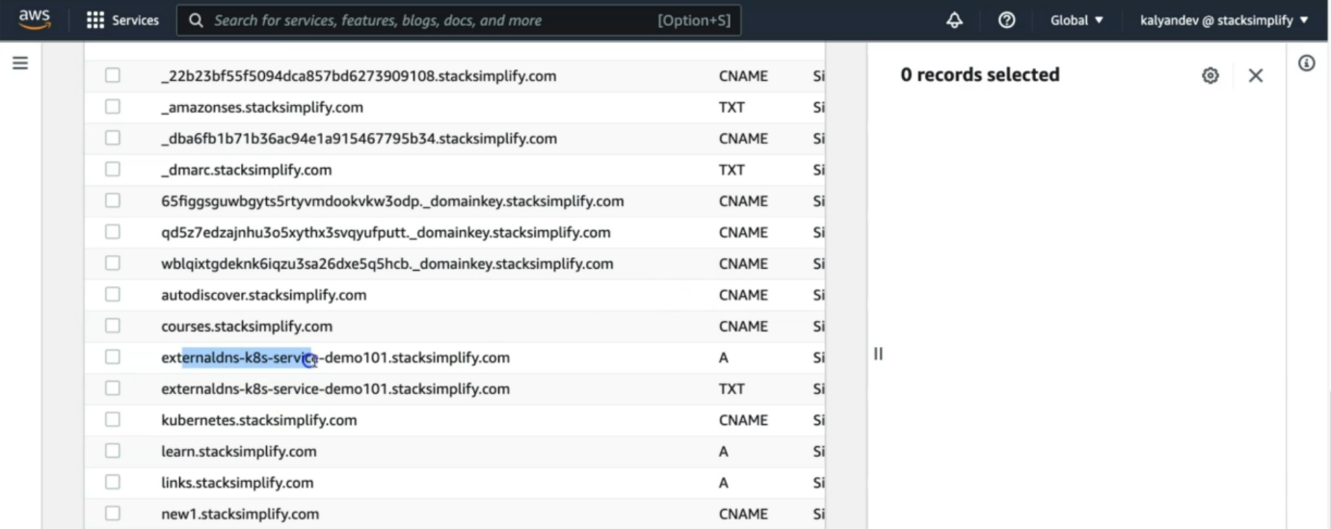

--- **note** – our external subdomain is created in hosted zones.

--- You should see Record Sets added for externaldns-k8s-service-demo101.stacksimplify.com

**Access Application using newly registered DNS Name**

--- Perform nslookup tests before accessing Application

--- Test if our new DNS entries registered and resolving to an IP Address

**# nslookup commands**

--- **nslookup externaldns-k8s-service-demo101.stacksimplify.com**

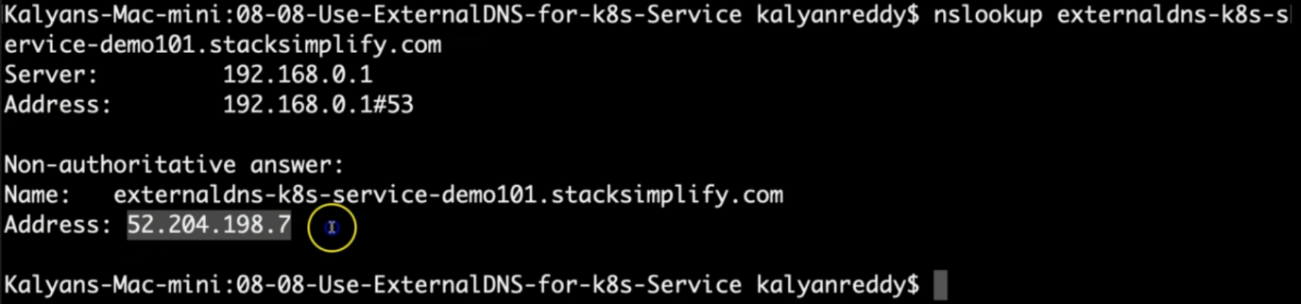

--- the domain is resolved to ip address.

**Access Application using DNS domain**

**# HTTP URL**

--- **http://externaldns-k8s-service-demo101.stacksimplify.com/app1/index.html**

**Clean Up**

**# Delete Manifests**

--- **kubectl delete -f kube-manifests/**

**## Verify Route53 Record Set to ensure our DNS records got deleted**

--- Go to Route53 -> Hosted Zones -> Records

--- The below records should be deleted automatically

--- externaldns-k8s-service-demo101.stacksimplify.com

**References**

--- <https://github.com/kubernetes-sigs/external-dns/blob/master/docs/tutorials/alb-ingress.md>

--- <https://github.com/kubernetes-sigs/external-dns/blob/master/docs/tutorials/aws.md>